TEAM 5

Rope climbing robot is one of many kinds of mobile robots that can maneuver in the environment using a locomotion mechanism. Rope climbing robots can move over the rope/wire using a specially designed locomotion mechanism. The project aims to design and develop a rope climbing robot that can travel over the rope steadily and easily with inclination upto 45 degree. The robot has a facility to adjust the rope tension which may get lost over the period of time. A rope climbing robot can be used at places such as detecting faults in voltage transmission lines, to transfer any necessity during calamity or disaster from one place to another and record any event from various angles. The robot can inspect the wire rope at any height which is dangerous for humans to do. This Rope climbing bot is used to climb ropes in an easy and efficient manner to reduce manual labour.Motorised rollers are used for climbing and a leadscrew is used for the gripping.

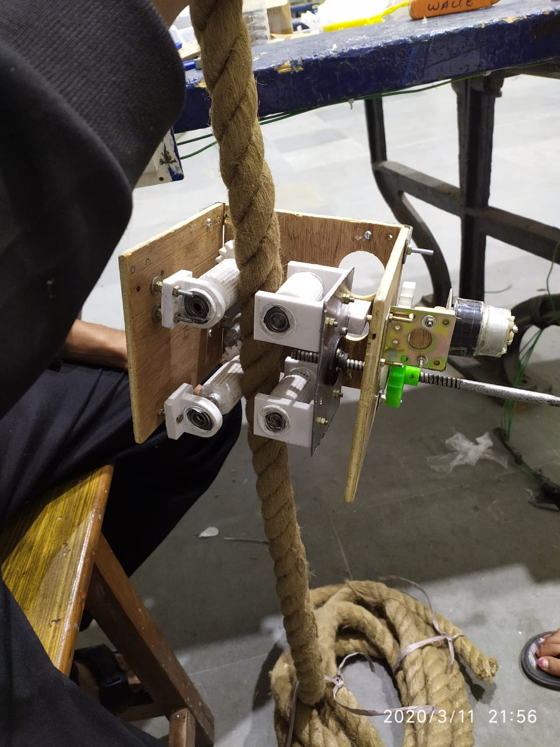

In rope climbing robot two aspects are especially important grip on the rope and smoothness while movement .  
These two characteristics are important to carry a weight with a robot and easily maintain a overall stability of the robot . The design presented here for rope climmbing is a wheel based system since they are highly and easy to build

REFERENCE:--

<https://www.arrow.com/en/research-and-events/articles/ultrasonic-sensors-how-they-work-and-how-to-use-them-with-arduino>  
<https://www.thomasnet.com/articles/machinery-tools-supplies/pneumatic-actuators/>  
<https://www.instructables.com/circuits/arduino/projects/>  
<https://grabcad.com/>